Dear {Name},

Greetings from Vietnam!

My name is Marcus, and I am with ALT LOGISTICS JSC (AN LOC THINH LOGISTICS JOINT STOCK COMPANY), a trusted logistics service provider in Vietnam.
I am pleased to introduce our company and explore potential cooperation opportunities with your esteemed organization.
With extensive experience in international freight forwarding and supply chain solutions, we provide reliable and cost-effective logistics services, including:
1. Air Freight
Competitive airfreight solutions from SGN, HAN, and DAD airports to China, Europe, the USA, and worldwide destinations through major airlines such as PR, NH, OZ, TK, EK, EY, BA, PO, 5X, QY, CZ, MU, CK, RH, and CX.
2. Ocean Freight
Competitive rates and reliable services to:
- USA: LAX, LGB, OAK, SEA, NYC, SAV, HOU, CHI via ONE, YML, CMA, MSC, ZIM...
- Europe: RTM, HAM, ANR, FXT, LEH, GOA via MSK, YML, EMC, MSC...
- China & Asia: SHA, NGB, TAO, TSN, XMN, SZX, HKG, KHH, SIN, via YML, COSCO, SJJ, RCL...
3. Customs Clearance
Professional customs brokerage services with experienced specialists ensuring compliance, efficiency, and maximum utilization of applicable customs incentives.
4. Domestic Trucking
Safe, flexible, and cost-effective transportation from seaports and airports to customers’ facilities across Vietnam.
5. Cross-border Transportation
Comprehensive cross-border logistics solutions between:
- Vietnam – China
- Vietnam – Laos
- Vietnam – Cambodia
6. SOC Solutions
Specialized handling of SOC containers, including storage, maintenance, repair, PTI, lift-on/lift-off, shipside operations, container trading, and booking support.
7. Warehousing Services
We offer:
- General warehousing
- Short-term and long-term storage
- Bonded warehouse solutions for import, re-export, and distribution activities
At ALT Logistics, we are committed to providing dependable logistics support and creating value for our partners in Vietnam.
Should you have any logistics inquiries, shipment opportunities, or customers requiring support in Vietnam, we would be delighted to assist.
We look forward to hearing from you and exploring how we can support your business.

Thanks and Best Regards  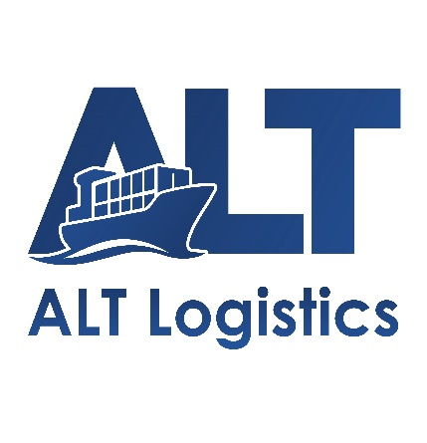   | Mr Marcus Nguyen  Overseas Agent Department  AN LOC THINH LOGISTICS JOINT STOCK COMPANY –  ALT LOGISTICS JSC  Ha Noi/Ho Chi Minh/Hai Phong offices  Head Office: 4th Floor, UP Office Building, No. 15/259 Yen Hoa Street, Yen Hoa Ward, Hanoi, Vietnam  Website: https://altlog.vn/  Email: Marcus@altlog.vn  WhatsApp/ Zalo: (+84) 398998159 Wechat: marcus_nguyen_altlog  Mobile: (+84) 398998159 Tel: (+84) 24 62810994

